Please note that this information is strictly embargoed until February 1, 2023, 6 a.m. PST
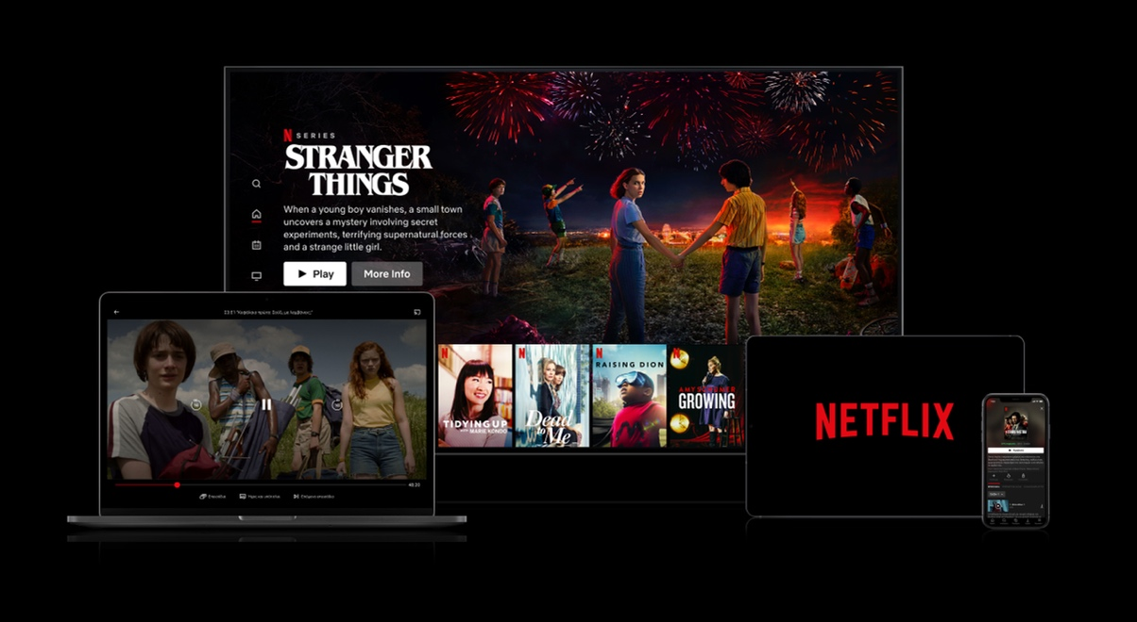
Collage courtesy of Netflix

Netflix spatial audio powered by Sennheiser
Streaming giant chooses AMBEO 2-Channel Spatial Audio for its enhanced Premium plan

Wedemark, February 1, 2023– Netflix has announced a series of brand-new features for members on its Premium plan, including Netflix spatial audio. Starting today, members on Netflix’s Premium plan using a stereo system will experience immersive cinematic audio on more than 700 top titles – all on their existing hardware. Netflix spatial audio is powered by Sennheiser’s AMBEO 2-Channel Spatial Audio technology.

Developed in partnership with Netflix, this Sennheiser technology delivers an unrivalled immersive experience over stereo speakers while fully respecting the creative intent of the original surround or immersive mix. Netflix members do not need any additional hardware to experience this new benefit.

Renato Pellegrini, Manager Pro Labs, AMBEO Immersive Audio: “We are very pleased that Netflix has expanded its partnership with Sennheiser and has chosen to roll out our game-changing AMBEO 2-Channel Spatial Audio experience to more of its catalog.”

New Surround to 2-Channel Rendering
In addition to content mixed for Dolby Atmos®, Netflix’s spatial audio catalog will also include non-Atmos® surround content. “As a brand-new feature, the AMBEO 2-Channel Spatial Audio renderer is now also able to process surround mixes, unlocking huge catalogs of content available in these formats,” shares Pellegrini. “For members on Netflix’s Premium plan, this means they will be able to enjoy more of their favorite content immersively, however they watch.”

Respectful Rendering
As a company that counts many mix and (re-)recording engineers among its customers, Sennheiser takes audio quality and mixer intent seriously. AMBEO 2-Channel Spatial Audio rendering was created hand-in-hand with mixers and provides them with granular control of the amount of spatialization.

A preview tool allows mixers to compare standard stereo to AMBEO and adjust rendering settings by individual stems or groups. Specific stems, such as dialog, can be completely excluded from spatialization and music mixes can be kept on their left and right channels while immersive rendering is applied to any other stems. The renderer seeks to translate mixer intent while giving an impressive immersive audio experience previously inaccessible on two speakers.

Hear the difference at https://youtu.be/0RMh2LnJeGY

Experience It Today
Members on Netflix’s Premium plan can experience AMBEO 2-Channel Spatial Audio on hundreds of Netflix’s most popular titles, including Stranger Things, The Watcher, Wednesday, and Knives Out: Glass Onion. Netflix will add forthcoming titles, such as You, Your Place or Mine, and Luther: The Fallen Sun.

For an up-to-date list of content available in spatial audio, Netflix members can simply enter “Spatial Audio” in the Netflix search field or look for the new Netflix spatial audio badge.

To learn more about AMBEO 2-Channel Spatial Audio, please visit www.sennheiser.com/ambeo-spatial-audio

The images accompanying this media release can be downloaded here.
Dolby Atmos is a trademark of Dolby Laboratories Licensing Corporation.

About the Sennheiser Group

Building the future of audio and creating unique sound experiences for our customers - this is the aspiration that unites the employees of the Sennheiser Group worldwide. The independent family-owned company Sennheiser was founded in 1945. Today, it is managed in the third generation by Dr. Andreas Sennheiser and Daniel Sennheiser, and is one of the leading manufacturers in the field of professional audio technology. Within the Sennheiser Group are Georg Neumann GmbH (Berlin, Germany), manufacturer of studio-grade audio equipment; Dear Reality GmbH (Düsseldorf, Germany), known for its binaural, Ambisonics, and multichannel encoders with realistic room virtualization; and Merging Technologies SA (Puidoux, Switzerland), specialist in high-resolution digital audio recording systems.
sennheiser.com | neumann.com | dear-reality.com | merging.com

Global Pro Audio Press Contact
Stephanie Schmidt
stephanie.schmidt@sennheiser.com
+49 (5130) 600 – 1275

